Parser

🧠 What is a Parser?
# Source: AI Source: Provided by: [Data Path: Persons Table -> ID Column: 1, Name_En Column: Motasem Essam] -> From: [Chatgpt (GPT‑5 Mini)] on [1/26/2026]
A parser is a program or component that reads input data (like code, markup, or configuration files) and analyzes its structure according to a set of rules.

🔹 In Simple Terms:
# Source: AI Source: Provided by: [Data Path: Persons Table -> ID Column: 1, Name_En Column: Motasem Essam] -> From: [Chatgpt (GPT‑5 Mini)] on [1/26/2026]
A parser breaks down text into parts the computer can understand and work with — like a translator between human-readable text and machine-usable structure.

🧾 Example with XML:
# Source: AI Source: Provided by: [Data Path: Persons Table -> ID Column: 1, Name_En Column: Motasem Essam] -> From: [Chatgpt (GPT‑5 Mini)] on [1/26/2026]
Given this XML:
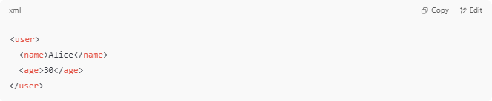
<user>
<name>Alice</name>
<age>30</age>
</user>

An XML parser reads this and understands:
- user is the root element
- name is a child with value "Alice"
- age is a child with value "30"
It turns the text into a structured format the computer can use (like a tree or object).

🔸 Where Parsers Are Used:
# Source: AI Source: Provided by: [Data Path: Persons Table -> ID Column: 1, Name_En Column: Motasem Essam] -> From: [Chatgpt (GPT‑5 Mini)] on [1/26/2026]
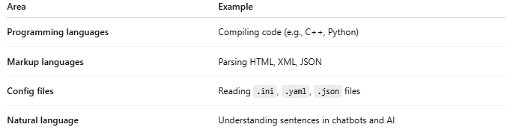
Area | Example
Programming languages | Compiling code (e.g., C++, Python)
Markup languages | Parsing HTML, XML, JSON
Config files | Reading .ini, .yaml, .json files
Natural language | Understanding sentences in chatbots and AI

What is a parser and how to use it
# Source: Wiki source: Provided by: [Data Path: Persons Table -> ID Column: 1, Name_En Column: Motasem Essam] -> From: [Data Path: Sources Table -> ID Column: 283, Content Title Column: What is a parser and how to use it] -> at: [Document, page: 1, Top, “Parsing is a way... application or script.”] on [7/14/2025]
Parsing is a way of indexing information with its further transformation into another format, and in some cases even another kind of data.

For example, letʼs take an HTML file. Parsing will allow you to convert the information from this file into solid text, thereby making it readable. Another option is to transform HTML into JSON for subsequent work in an application or script.

🔧 What Does a Parser Do?
# Source: AI Source: Provided by: [Data Path: Persons Table -> ID Column: 1, Name_En Column: Motasem Essam] -> From: [Chatgpt (GPT‑5 Mini)] on [1/26/2026]
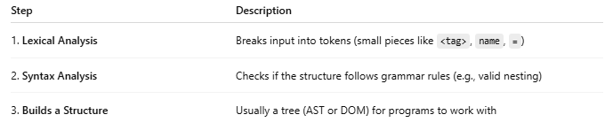
Step | Description
1. Lexical Analysis | Breaks input into tokens (small pieces like <tag>, name, =)
2. Syntax Analysis | Checks if the structure follows grammar rules (e.g., valid nesting)
3. Builds a Structure | Usually a tree (AST or DOM) for programs to work with

🧠 Types of Parsers
# Source: AI Source: Provided by: [Data Path: Persons Table -> ID Column: 1, Name_En Column: Motasem Essam] -> From: [Chatgpt (GPT‑5 Mini)] on [1/26/2026]
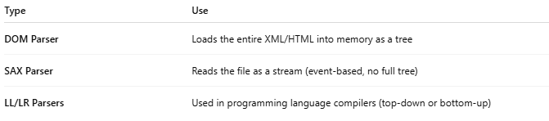
Type | Use
DOM Parser | Loads the entire XML/HTML into memory as a tree
SAX Parser | Reads the file as a stream (event-based, no full tree)
LL/LR Parsers | Used in programming language compilers (top-down or bottom-up)

✅ Real-World Examples
# Source: AI Source: Provided by: [Data Path: Persons Table -> ID Column: 1, Name_En Column: Motasem Essam] -> From: [Chatgpt (GPT‑5 Mini)] on [1/26/2026]
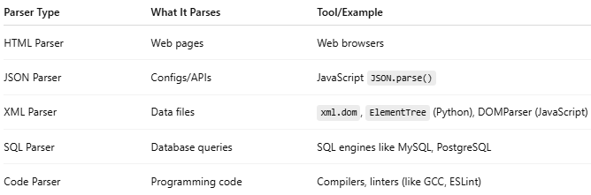
Parser Type | What It Parses | Tool/Example
HTML Parser | Web pages | Web browsers
JSON Parser | Configs/APIs | JavaScript JSON.parse()
XML Parser | Data files | xml.dom, ElementTree (Python), DOMParser (JavaScript)
SQL Parser | Database queries | SQL engines like MySQL, PostgreSQL
Code Parser | Programming code | Compilers, linters (like GCC, ESLint)

🧩 Summary
# Source: AI Source: Provided by: [Data Path: Persons Table -> ID Column: 1, Name_En Column: Motasem Essam] -> From: [Chatgpt (GPT‑5 Mini)] on [1/26/2026]
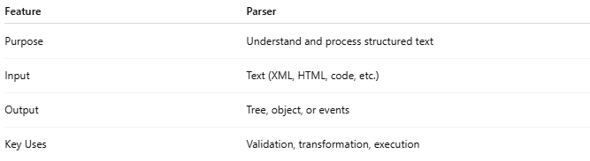
Feature | Parser
Purpose | Understand and process structured text
Input | Text (XML, HTML, code, etc.)
Output | Tree, object, or events
Key Uses | Validation, transformation, execution

Would you like to see a visual example of how a parser builds a tree from XML, or how to write a simple parser in Python or JavaScript?

